PUPIL ATTENDANCE POLICY



Approved by Governors: | 8th September 2026
Key staff: | Manjit Hazle
Review date: | September 2027 (annually, following DfE and Essex updates)

At HRS all staff work together to improve attendance and the life chances of pupils.

The name and contact details of the school staff member pupils and parents should contact about attendance on a day-to-day basis is:
Primary: Bev Louth
Secondary: Nicola Sparrow
Sixth Form: Paula Barry

The name and contact details of the school staff member pupils and parents should contact for more individual support with attendance are:

Year 7 | Meghan Maybanks | mmaybanks@hrs.education
Year 8 | Amy Snelling | asnelling@hrs.education
Year 9 | Daniella Kalejaiye | dkalejaiye@hrs.education
Year 10 | Becky Wyatt | bwyatt@hrs.education
Year 11 | Lucy Cook | lcook@hrs.attendance
All- primary  All- secondary  All- Sixth Form | Bev Louth  Bethany Smith  Paula Barry | primaryenquiries@hrs.education  attendance@hrs.education  pbarry@hrs.education
The names of the senior leaders responsible for the strategic approach to attendance in our school is:
Primary school: Jennifer Hone primaryenquiries@hrs.education
Secondary school: Manjit Hazle enquiries@hrs.education
Sixth Form: Russell Milne sixthformenquiries@hrs.education

The name of our linked Governor with responsibility for monitoring attendance is:
Mr Graham Oxborrow

Helena Romanes School

Pupil Attendance Policy

Introduction and Background

Helena Romanes school recognises that positive behaviour and good attendance are essential in order for pupils to get the most of their school experience, including their attainment, wellbeing and wider life chances.

The law entitles every child of compulsory school age to an efficient, full-time education suitable to their age, aptitude, and any special educational need they may have. It is the legal responsibility of every parent to make sure their child receives that education either by attendance at a school or by education otherwise than at a school.

Where parents decide to have their child registered at school, they have an additional legal duty to ensure their child attends that school regularly, on time. This means their child must attend every day that the school is open, except in a small number of allowable circumstances such as being too ill to attend or being given permission for an absence in advance from the school.

The Department for Education (DfE) has produced statutory guidance for maintained schools, academies, independent schools, and local authorities. It is called “Working together to improve school attendance” and it includes a National Framework in relation to absence and the use of legal sanctions. Our School Attendance Policy reflects the requirements and principles of that guidance.

This policy is written with the above guidance in mind and underpins our school ethos to:
- promote children’s welfare and safeguarding;
- ensure every pupil has access to the full-time education to which they are entitled;
- ensure that pupils succeed whilst at school;
- ensure that pupils have access to the widest possible range of opportunities at school, and when they leave school.

It has been developed in consultation with school governors, teachers, local Headteacher Associations, the Local Authority and parents and carers. It seeks to ensure that all parties involved in the practicalities of school attendance are aware and informed of attendance matters in school and to outline the school’s commitment to attendance matters. It details the responsibilities of individuals and groups involved and the procedures in place to promote and monitor pupil attendance.

In addition, all schools follow the DfE’s statutory safeguarding guidance, Keeping Children Safe in Education, which emphasises the importance of understanding the potential vulnerabilities of children who are missing or absent from education.
https://www.gov.uk/government/publications/keeping-children-safe-in-education--2

The DfE’s Suspension and Permanent Exclusion guidance should also be read in conjunction with the Attendance Policy for specific elements: Suspension and permanent exclusion guidance

Our policy aims to raise and maintain levels of attendance by:
- Promoting a positive and welcoming atmosphere in which pupils feel safe, secure and valued;
- Raising and maintaining a whole school awareness of the importance of good attendance and punctuality;
- Ensuring that attendance is monitored effectively and reasons for absences are recorded promptly and consistently.

For our children to gain the greatest benefit from their education it is vital that they attend regularly and be at school, on time, every day the school is open unless the reason for the absence is unavoidable. It is a rule of this school that pupils must attend every day, unless there are exceptional circumstances, and it is the headteacher, not the parent, who can authorise the absence.

Promoting Regular Attendance

At Helena Romanes school, we believe in developing good patterns of attendance and set high expectations for the attendance and punctuality for all our pupils from the outset. It is a central part of our school’s vision, values, ethos and day to day life. We recognise the strong connections between attendance, attainment, safeguarding and wellbeing.

Primary School: Jennifer Hone primaryenquiries@hrs.education
Secondary school: Manjit Hazle enquiries@hrs.education

The governor with responsibility for monitoring attendance is Mr Graham Oxborrow.

Helping to create a pattern of regular attendance is the responsibility of parents, pupils and all members of school staff.

To help us all to focus on this, we will:
- Submit a daily attendance return to the Department of Education, in line with the legal expectations placed on all schools;
- Build strong relationships and work jointly with families;
- Give parents/carers details on attendance in our newsletters;
- Promote the benefits of high attendance;
- Accurately complete admission and, with the exception of schools where all pupils are boarders, attendance registers and have effective day to day processes in place to follow-up absence as required by law;
- Celebrate excellent attendance
- Reward good or improving attendance;
- Link certificates, prizes, rewards and trips to attendance;
- Report to parents/carers regularly on their child’s attendance and the impact on their progress;
- Contact parents/carers should their child’s attendance fall below the school’s target for attendance.

Understanding Types of Absence

Any absence affects the routine of a child’s schooling and regular absence will seriously affect their learning journey and ability to progress. Any pupil’s absence or late arrival disrupts teaching routines and so may affect the learning of others in the same class. Ensuring a child’s regular attendance at school is a parental responsibility and allowing absence from school, without a good reason, creates an offence in law and may result in prosecution.

Every half-day absence from school has to be classified by the school (not by the parent), as either authorised or unauthorised. This is why information about the cause of any absence is always required. Each half-day is known as a ‘session’.

Authorised absences are morning or afternoon sessions away from school for a genuine reason such as illness (although you may be asked to provide medical evidence for your child before this can be authorised), medical or dental appointments which unavoidably fall in school time, emergencies or other unavoidable cause.

Unauthorised absences are those which the school does not consider reasonable and for which no ‘leave’ has been granted. This type of absence can lead to the school referring to the Local Authority for penalty notices and/or legal proceedings.

Unauthorised absence includes, (however this list is not exhaustive):
- parents/carers keeping children off school unnecessarily e.g. because they had a late night or for non-infectious illness or injury that would not affect their ability to learn;
- absences which have never been properly explained;
- children who arrive at school after the close of registration are marked using a ‘U’. This indicates that they are in school for safeguarding purposes, however is counted as an absence for the session;
- shopping trips;
- looking after other children or children accompanying siblings or parents to medical appointments;
- their own or family birthdays;
- holidays taken during term time, not deemed ‘for exceptional purposes’ by the headteacher, including any arranged by other family members or friends;
- day trips;
- other leave of absence in term time which has not been agreed.

Understanding when a child may be unwell but expected to be in school or when they are too ill for school

For our children to gain the greatest benefit from their education it is vital that they attend regularly and be at school, on time, every day the school is open unless the reason for the absence is unavoidable. It is a rule of this school that pupils must attend every day, unless there are exceptional circumstances, and it is the headteacher, not the parent, who can authorise the absence. As a school, we will work with you to offer support and encourage the attendance of a child who may be injured or feel unwell.

Appendix D: NHS, UK Health Security Agency and Essex County Council guidance
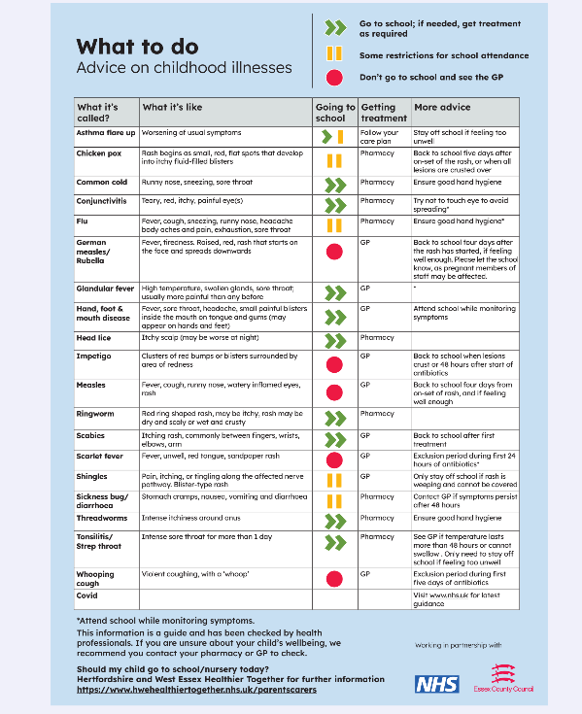 | 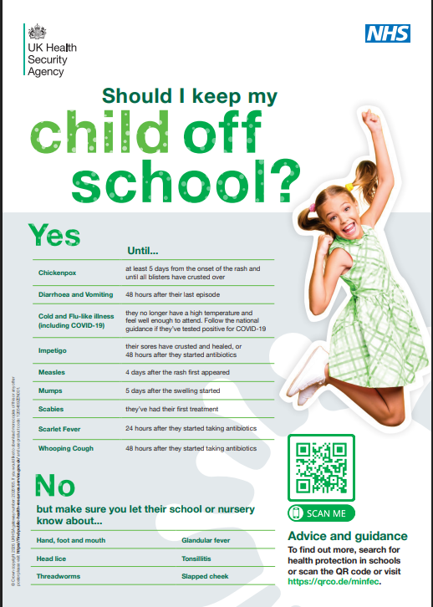

Persistent Absenteeism (PA) and Severe Absenteeism (SA)

A pupil is defined by the Government as a ‘persistent absentee’ when they miss 10% or more schooling across the school year for any reason; this can be authorised or unauthorised absence. Absence at this level will cause considerable damage to any pupil’s education and we need the full support and co-operation of parents to resolve this. All pupils who have attendance levels of 90% or below are considered to be a persistent absentee.

A pupil who has missed 50% or more schooling is defined by the Government as ‘severely absent’. Pupils within this cohort may find it more difficult to be in school or face bigger barriers to their regular attendance and, as such, are likely to need more intensive support.

Essex County Council: attendance and lost learning hours
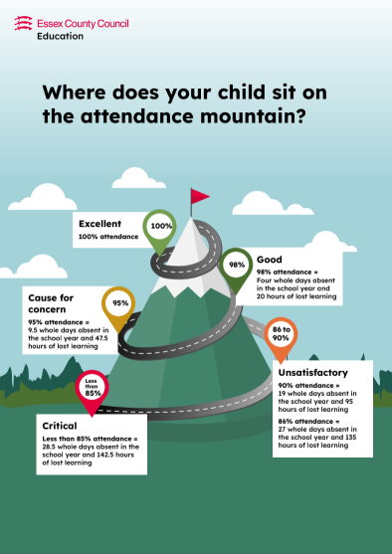 | 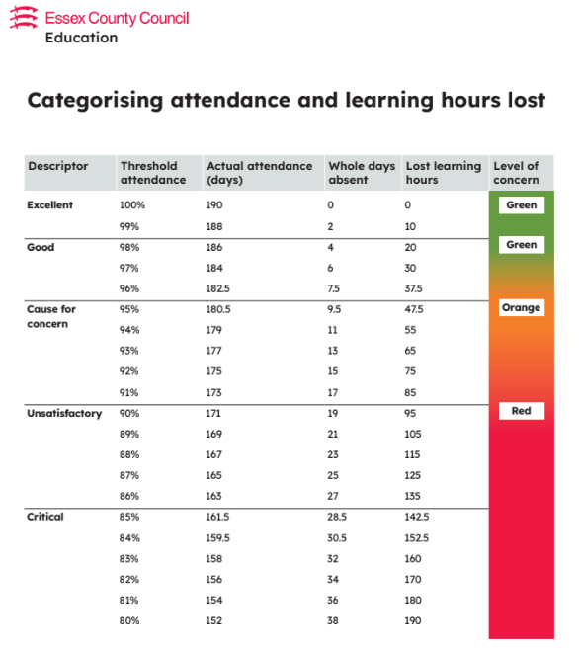

Absence Procedures

Primary: Bev Louth primaryenquiries@hrs.education

Secondary: Nicola Sparrow attendance@hrs.education

Sixth Form: Paula Barry pbarry@hrs.education

We monitor and review all pupils’ absence, and the reasons that are given, thoroughly.

If a child is absent from school the parent must follow these procedures:
Primary:

- Contact the school on the first day of absence before 8.45am. The school has an answer phone available to leave a message if nobody is available to take your call, or you may call into school personally and speak to the office staff. Please provide clear details of the reason for absence as ‘ill’ is not specific enough
- Contact the school on every further day of absence, again before 8.45am.
- Ensure that your child returns to school as soon as possible and you provide any medical evidence, if requested, to support the absence. Medical evidence may be requested where your child is having multiple periods of absence which are reported as being due to medical reasons.
- When determining whether a child is too ill to attend school, both parents and school staff can consider the advice contained within the NHS and Essex County Council Guidance on School Absence and Childhood Illness (appendix D).

Secondary and Sixth Form:

- Contact the school on the first day of absence ideally before 8.40am when registers open and ideally no later than 9.10 am, when our register closes, after which point your child will be registered with a code U;
- The school has an answer phone available to leave a message if nobody is available to take your call, or you may call into school personally and speak to the office staff. Alternatively, please report the absence on the school’s MIS system, Arbor. Please be aware that, if you leave a voicemail or a note on Arbor to report your child’s absence, you may receive a call from the school so that we may discuss the absence before making a decision as to whether the absence is to be recorded as authorised. If the absence is a planned future absence, such as an appointment, please email, with details/copies of appointments if possible to attendance@hrs.education.
- Contact the school on every further day of absence, again before before 8.40am when registers open and ideally no later than 9.10 am, when our register closes;
- Ensure that your child returns to school as soon as possible and you provide any medical evidence, if requested, to support the absence. Medical evidence may be requested where your child is having multiple periods of absence which are reported as being due to medical reasons. When determining whether a child is too ill to attend school, both parents and school staff can consider the advice contained within the NHS and Essex County Council Guidance on School Absence and Childhood Illness (appendix D).

If your child is absent we will:
- Telephone or text you on the first, and every subsequent day of absence, if we have not heard from you. However, it is your responsibility to contact us;
- If we are unable to make contact with parents by telephone, we will telephone emergency contact numbers, send letters home and a home visit may be made, in the interests of safeguarding;
- A referral will be made to Local Authority if no contact has been made with parents by the 10th day of absence (or sooner if deemed appropriate), at which point your child will be considered to be “missing from education.”
If absence continues we will:
- Write to you if your child’s attendance and/or where punctuality is a concern;
- Arrange a meeting so that you may discuss the situation with your child’s Head of Year, school Attendance Officer, senior leader from the pastoral/SEND/safeguarding team or Senior Attendance Champion
- Create a personalised action/support plan, such as an attendance contract, to address any barriers to attendance and make clear each person’s role in improving the attendance patterns of your child;
- Offer signposting support to other agencies or services, if appropriate;
- Refer the matter to the Local Authority for relevant legal sanctions, if attendance deteriorates following the above actions.

Sixth Form attendance Procedures:

Procedures in the Sixth Form are slightly different as students could choose other forms of training or employment. By accepting a place in the Sixth Form, students and parents are entering into an agreement to accept the terms of our attendance policy. If, after a staged intervention to support attendance, there is still persistent or severe absence, then the school will withdraw the place for the student and they will be asked to leave. More detail surrounding absence procedures in the Sixth Form can be found linked in the appendices.

Lateness

Poor punctuality is not acceptable and can sometimes lead to irregular school attendance patterns. Good time-keeping is a vital life skill which will help children as they progress through their school life and out into the wider world.

Pupils who arrive late disrupt lessons and, if a child misses the start of the day, they can feel unsettled and embarrassed and risk missing vital work and important messages from their class teacher.

The times of the start and close of the school day for all pupils at Helena Romanes School are:

Primary:

Gates open: 8.50 am
Morning Registration starts: 9.00 am
Morning Registration closes: 9.30am
Afternoon Registration starts:1.05pm (Reception and Year 1) 1.15pm (Year 2-6)
Afternoon Registration closes:1.35pm (Reception and Year 1) 1.45pm (Year 2-6)
End of the school day: 3.40 pm

- The school day starts at 9am when children should be in registration.
- Registers are taken from 9am.
- Children arriving after 9am are required to come to the main office to be signed in and provide a reason for their lateness which is recorded.
- At 9.30am the registers will be closed. In accordance with the regulations, if your child arrives after that time, they will receive a mark that shows them to be on site - ‘U’, but this will not count as a present mark and it will mean that they have an unauthorised absence.
- The school may contact parents/ carers regarding punctuality concerns.

Secondary:

Pupils should aim to be at school for 8.30am to allow time to complete Yondr checks and get to registration rooms.
Gates open: 8.15am
Morning Registration starts: 8.40am
Morning Registers close: 9.10am
Afternoon Registration starts: 12.30pm
Afternoon Registration closes: 1:00pm
End of the school day: 3.20pm

- The school day starts at 8.40am when children should be in registration;
- Registers are taken from 8.40am;
- Children arriving after 8.55am are required to come into school via the Late Gate at Student Reception and provide a reason for their lateness, which is recorded.
Parents should not drop children beyond the point of Student Reception.
- At 9.10am the registers will be closed. In accordance with the Regulations, if your child arrives after that time, they will receive a mark that shows them to be on site – ‘U’, but this will not count as a present mark and it will mean that they have an unauthorised absence;
- The school may contact parents/carers regarding punctuality concerns;
- Each day a member of school staff will undertake a ‘Late Gate’ check, greeting late arrivals at the student entrance to the school.
Unauthorised lateness could result in the school referring to the Local Authority for sanctions and/or legal proceedings. If your child has a persistent lateness record, you may be asked to meet with a pastoral leader, Head of Year, Attendance Lead or a senior leader from the pastoral/SEND/safeguarding team, but you can approach us at any time if you are having difficulties getting your child to school on time. We expect parents and staff to encourage good punctuality by being good role models to our children and, as a school, we celebrate good class and individual punctuality.

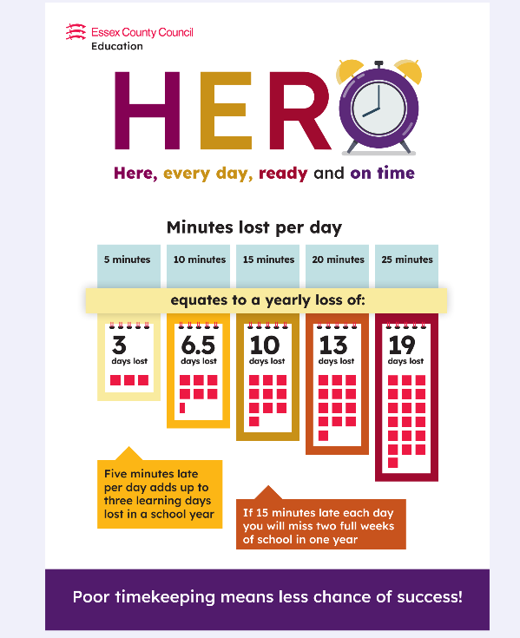

Understanding barriers to attendance

Whilst any child may occasionally have time off school because they are too unwell to attend, sometimes they can be reluctant to attend school. Any barriers preventing regular attendance are best resolved between the school, the parents and the child. If a parent thinks their child is reluctant to attend school, then we will work with that family to understand the root problem and provide any necessary support. We can use outside agencies to help with this, such as the School Nurse, Mental Health and Emotional Wellbeing support services, a Child and Family Support Worker or the relevant Local Authority team/s. Where outside agencies are supporting the family, you may be invited to attend a Team Around the Family meeting (TAF) to consider what is working well and what needs to improve. An individual support plan will be agreed and subsequently reviewed.

Some pupils face greater barriers to attendance than their peers. These can include pupils who suffer from long-term medical conditions or who have special educational needs and disabilities, or other vulnerabilities. High expectations of attendance remain in place for these pupils, however we will work with families and pupils to support improved attendance whilst being mindful of the additional barriers faced. We can discuss reasonable adjustments and additional support from external partners, where appropriate.

Under the DfE’s statutory guidance, schools are required to submit a sickness return to the Local Authority for all pupils who have missed/are likely to miss 15 or more school days (consecutive or cumulative) due to medical reasons/illness.

See Annex A for summary tables of responsibilities for school attendance.

The name and contact details of the school staff member pupils and parents should contact for more detailed support on attendance:

Primary: Bev Louth: primaryenquiries@hrs.education

Secondary: Bethany Smith: bsmith@hrs.education

Sixth Form: Russell Milne, Director of Sixth Form; rmilne@hrs.education

Local Authority attendance support services

Local Authority Attendance Specialists work strategically by offering support to schools, to reduce persistent absence and improve overall attendance.

Parents are expected to work with the school and local authority to address any attendance concerns. Parents should proactively engage with the support offered, aiming to resolve any problems together. This is nearly always successful. If difficulties cannot be resolved in this way, the school may consider more formal support and/or refer the child to the Local Authority. If attendance does not improve, legal action may be taken in the form of a Penalty Notice (see Annex B for the Essex Code of Conduct) or prosecution in the Magistrates Court.

School Attendance and the Law

New legislation was passed, The School Attendance (Pupil Registration) (England) Regulations 2024 which introduced a National Framework in England. By law all children of compulsory school age must receive an appropriate full-time education (Education Act 1996). Parents have a legal duty to ensure their child attends school regularly at the school at which they are registered.

Parents may be recognised differently under education law, than under family law. Section 576 of the Education Act 1996 states that a ‘parent’, in relation to a child or young person, includes any person who is not a parent (from which can be inferred ‘biological parent’) but who has parental responsibility, or who has care of the child.

A person typically has care of a child or young person if they are the person with whom the child lives, either full or part time and who looks after the child, irrespective of what their biological or legal relationship is with the child.

National Framework for Penalty Notices

There is now a single consistent national threshold for when a penalty notice must be considered by all schools in England, of 10 sessions (usually equivalent to 5 school days) of unauthorised absence within a rolling 10 school week period. The 10 sessions of absence do not have to be consecutive and can be made up of a combination of any type of unauthorised absence (G, O and/or U coded within the school’s registers). The 10 school week period can span different terms, school years or education settings.

Sanctions may include issuing each parent (for each child) with a Penalty Notice for £160, reduced to £80 if paid within 21 days (for the first offence). A second Penalty Notice issued within a three year period will result in a fine of £160 per parent, per child. If a third offence is committed the matter may be referred to the local authority for consideration of prosecution via the Magistrates Court. If prosecution is instigated for irregular school attendance, each parent may receive a fine of up to £2500 and/or up to 3 months in prison. If a parent is found guilty in court, they will receive a criminal conviction.

See Annex B for the Essex Code of Conduct.

There is no entitlement in law for pupils to take time off during the term to go on holiday or other absence for the purpose of leisure or recreation, or to take part in protest activity in school hours. In addition, the Supreme Court has ruled that the definition of regular school attendance is “in accordance with the rules prescribed by the school.”

The School Attendance (Pupil Registration) (England) Regulations 2024 set out the statutory requirements for schools. All references to family holidays and extended leave have been removed. The amendments specify that headteachers may not grant any leave of absence during term time unless there are "exceptional circumstances" and they do not have any discretion to authorise up to ten days of absence each academic year.

It is a rule of this school that a leave of absence shall not be granted in term time unless there are reasons considered to be exceptional by the headteacher, irrespective of the child’s overall attendance. Only the headteacher or his/her designate (not the local authority) may authorise such a request and all applications for a leave of absence must be made in writing, in advance, on the prescribed form provided by the school. The school will usually consider that the parent who has made the application is therefore allowing the leave of absence, and also that all parents who are on the holiday are allowing the leave. Where a parent removes a child after their application for leave was refused or where no application was made to the school, the absence will be recorded as unauthorised. It is likely that penalty notices will be requested, in line with the National Framework and Essex Code of Conduct, in respect of each parent believed to have allowed the absence.

At Helena Romanes 'exceptional circumstances' will be interpreted as:
... being of unique and significant emotional, educational or spiritual value to the child which outweighs the loss of teaching time (as determined by the headteacher). The fundamental principles for defining ‘exceptional’ are events that are “rare, significant, unavoidable and short”. By 'unavoidable' we mean an event that could not reasonably be scheduled at another time, outside of school term time, regardless of who has planned or paid for the holiday or absence (including grandparents or other family or friends).

The headteacher/school may discuss the leave of absence request with other education settings and/or the Local Authority to determine any exceptional circumstances.

If leave of absence is authorised, the school will not provide work for children to do during their absence. Parents are however advised to read with their children and encourage them to write a diary while they are away.

Deletion from Roll

For any pupil leaving Helena Romanes Primary phase, other than at the end of year 6 or leaving Helena Romanes Secondary phase other than at the end of year 11, parents/carers are required to provide the school with the following information: Child’s name, class, current address, date of leaving, new home address, name of new school, address of new school. This information is essential to ensure that we know the whereabouts and may appropriately safeguard all of our pupils, even those who leave us.

It is crucial that parents keep school updated with current addresses and contact details for the pupil and key family members, in case of emergency.

Under Pupil Regulations 2006, all schools are now legally required to notify their Local Authority of every new entry to the admission register within five days of the pupil being enrolled. In addition to this, every deletion from the school register must also be notified to the Local Authority, as soon as the ground for deletion has been met in relation to that pupil, and in any event no later than the time at which the pupil’s name is deleted from the register. This duty does not apply when a pupil’s name is removed from the admission register at a standard transition point – when the pupil has completed the final year of education normally provided by that school.

Absence data

We use data to monitor, identify and support individual pupils or groups of pupils when their attendance needs to improve, and schools are required to submit pupil attendance data to the Department for Education on a daily basis Education (Information about Individual Pupils) (England) (Amendment) Regulations 2024. Persistently and severely absent pupils are tracked and monitored carefully. We also combine this with academic tracking, as increased absence affects attainment.

We share information and work collaboratively with other schools in the area, local authorities, and other partners, when absence is at risk of becoming persistent or severe.

Annex A: DfE guidance Summary table of responsibilities for school attendance. From 19th August 2024
https://assets.publishing.service.gov.uk/media/65e8ae343649a2001aed63aa/Summary_table_of_responsibilities_for_school_attendance__applies_from_19_August_2024_.pdf

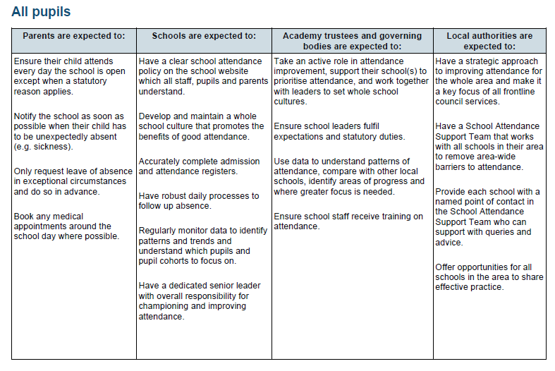

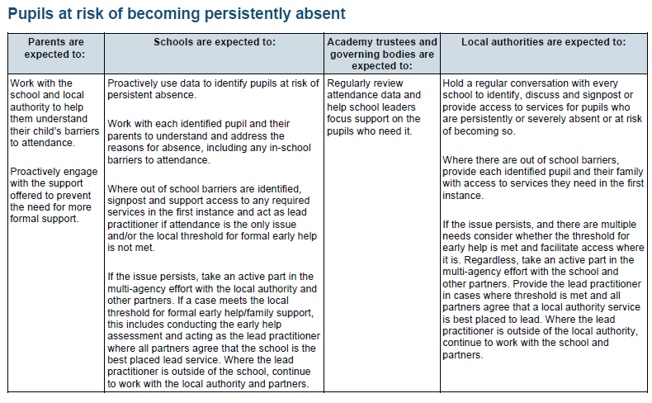
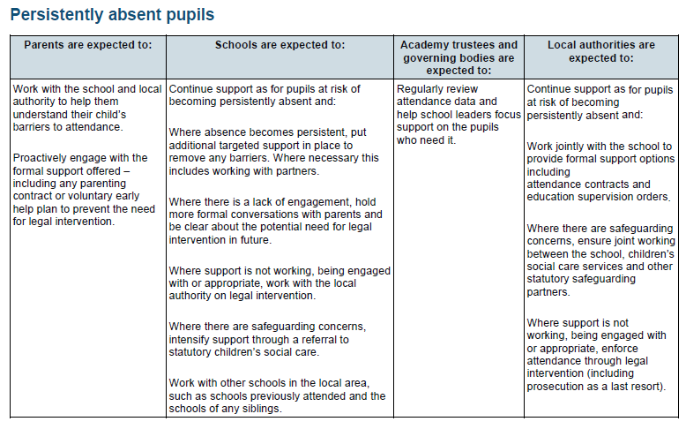

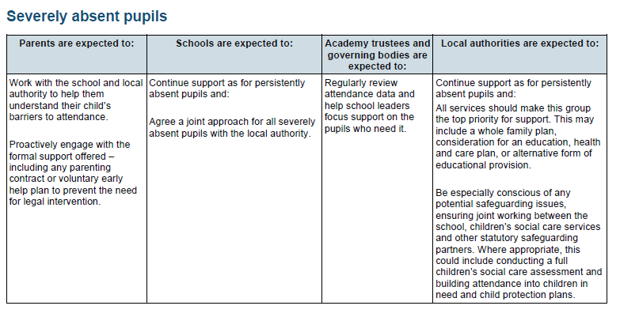

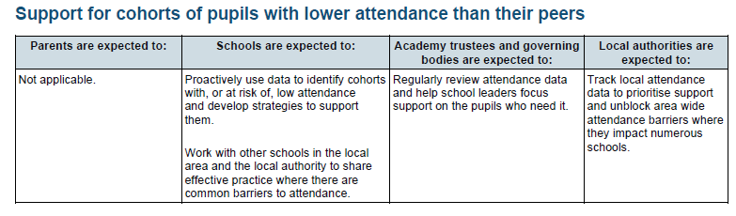
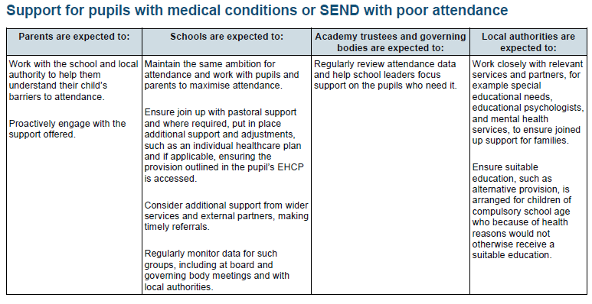
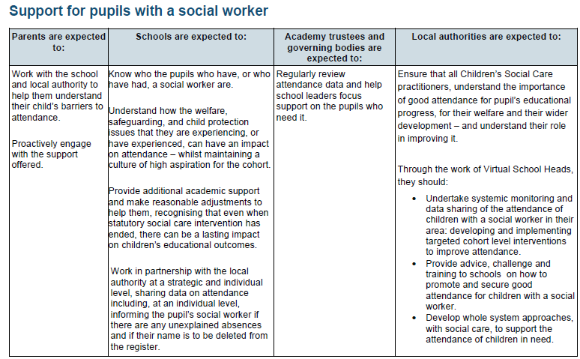

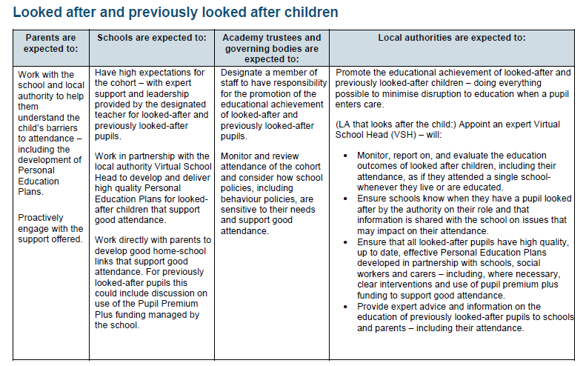

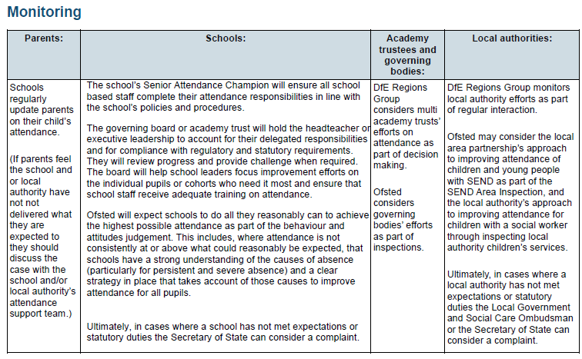

Annex B

ESSEX CODE OF CONDUCT: PENALTY NOTICES FOR PARENTS OF TRUANTS AND PARENTS OF PUPILS EXCLUDED FROM SCHOOL ANTI-SOCIAL BEHAVIOUR ACT 2003 SECTION 23

https://www.essex.gov.uk/schools-and-learning/schools/school-attendance-and-absence/penalty-notices

Annex C

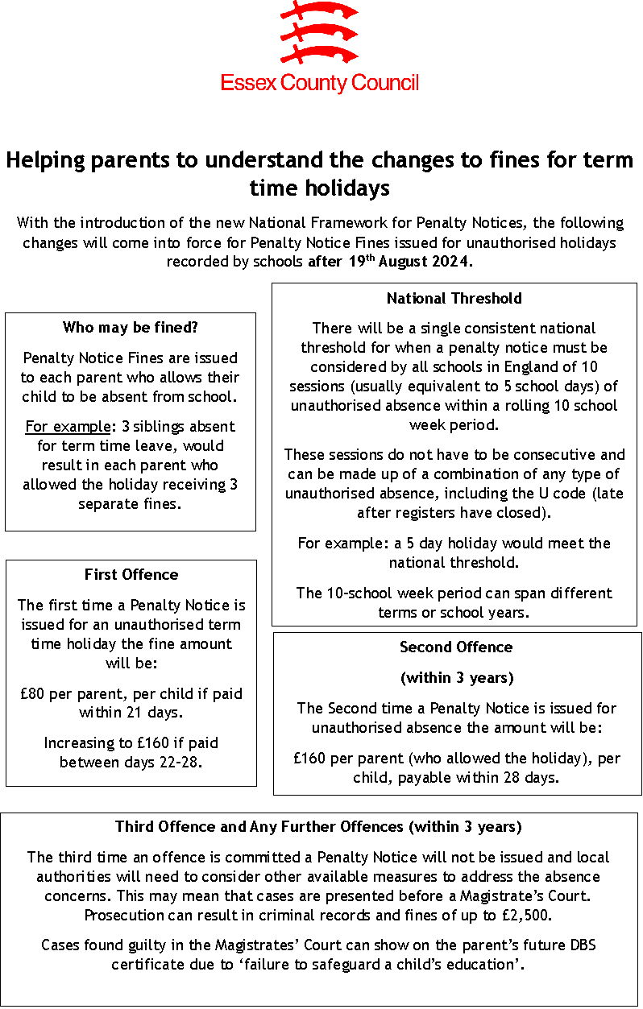

Annex D – Illness Absence Guidance

https://secureschools.essex.gov.uk/DisplayDocument.aspx?DocID=276

https://assets.publishing.service.gov.uk/media/626669cb8fa8f523b7221b98/UKHSA-should-I-keep-my_child_off_school_guidance-A3-poster.pdf

DfE external document template (childrenscommissioner.gov.uk)

